**Making Sense of the Census**

*A census is the government’s way of collecting data about their country’s population. In Australia, citizens are required to complete a census every five years.*

|  |  |  |  |
| --- | --- | --- | --- |
| **1947 Census** | | | |
| **Ranking** | **Birthplace** | **Number** | **%** |
| **1** | United Kingdom | 496 454 | 66.7 |
| **2** | Ireland | 44 813 | 6.0 |
| **3** | New Zealand | 43 610 | 5.9 |
| **4** | Italy | 33 632 | 4.5 |
| **5** | Germany | 12 291 | 1.7 |
| **6** | Greece | 9863 | 1.2 |
| **7** | India / Sri Lanka | 8160 | 1.1 |
| **8** | Poland | 6573 | 0.9 |
| **9** | China | 6404 | 0.9 |
| **10** | USA | 6232 | 0.8 |
|  | Top Ten Total | 672 736 | 90.4 |
|  | Other | 71 451 | 9.6 |
|  | **Total Born Overseas** | **744 187** | **100.00** |

|  |  |  |  |
| --- | --- | --- | --- |
| **2011 Census** | | | |
| **Ranking** | **Birthplace** | **Number** | **%** |
| **1** | United Kingdom | 1 101 100 | 20.8 |
| **2** | New Zealand | 483 400 | 9.1 |
| **3** | China | 319 000 | 6.0 |
| **4** | India | 295 400 | 5.6 |
| **5** | Italy | 185 400 | 3.5 |
| **6** | Vietnam | 185 000 | 3.5 |
| **7** | Philippines | 171 200 | 3.2 |
| **8** | South Africa | 145 700 | 2.8 |
| **9** | Malaysia | 116 200 | 2.2 |
| **10** | Germany | 108 000 | 2.0 |
|  | Top Ten Total | 3 002 400 | 58.8 |
|  | Other | 2 183 800 | 41.2 |
|  | **Total Born Overseas** | **5 186 200** | **100.00** |

***Refer to the data in the tables above and answer the following questions in full sentences:***

1. What world event can you see reflected in the figures in the 1947 Census?

Most of the migrants are from Europe as the war displaced many people there

1. Which continent/s features most and least heavily in the 1947 data? Why is this?

Countries in war destroyed countries in Europe because those people were displaced

1. Which continent/s feature most heavily in the 2011 data? Why is this?

Europe and Asia features most heavily in the graph, this is because most people live in Europe and Asia

1. Locate continuities (something that has stayed the same) across both sets of data.  
    Both sets of data have heavy migration from Europe
2. What do you notice about the overall numbers of Australian citizens born overseas from 1947 to 2011? What does this suggest?  
    It has increased to 5 times the amount in 1947, this means that there are many more migrants living in Australia than 1947
3. Locate and summarise any other changes across both sets of data. Why do you think there have been such changes?

The percentage of migrants from UK have been halved and many more migrants come from Asia instead of wider Europe, also the amount of countries that Australia excepts migrants from has increased.

1. Using the data tables, construct a pie chart for both the 1947, 2011 and 2016 Census figures:
   * You should use the ‘Birthplace’ and ‘Percentage’ columns as your data
   * Give your pie charts appropriate titles
   * Include a copy of each pie chart in this document on the next page

**1947, 2011 & 2016 Overseas Birth Graphs**

***\*insert your completed graphs here\****

1947:

2011:

2016:

**2016 Overseas Birth Map**

1. Access the following link: <https://mapchart.net/world.html>
2. Create a map that highlights the Top 10 Countries by Birth, according to the 2016 Census
3. When complete, download your map and paste into this document3

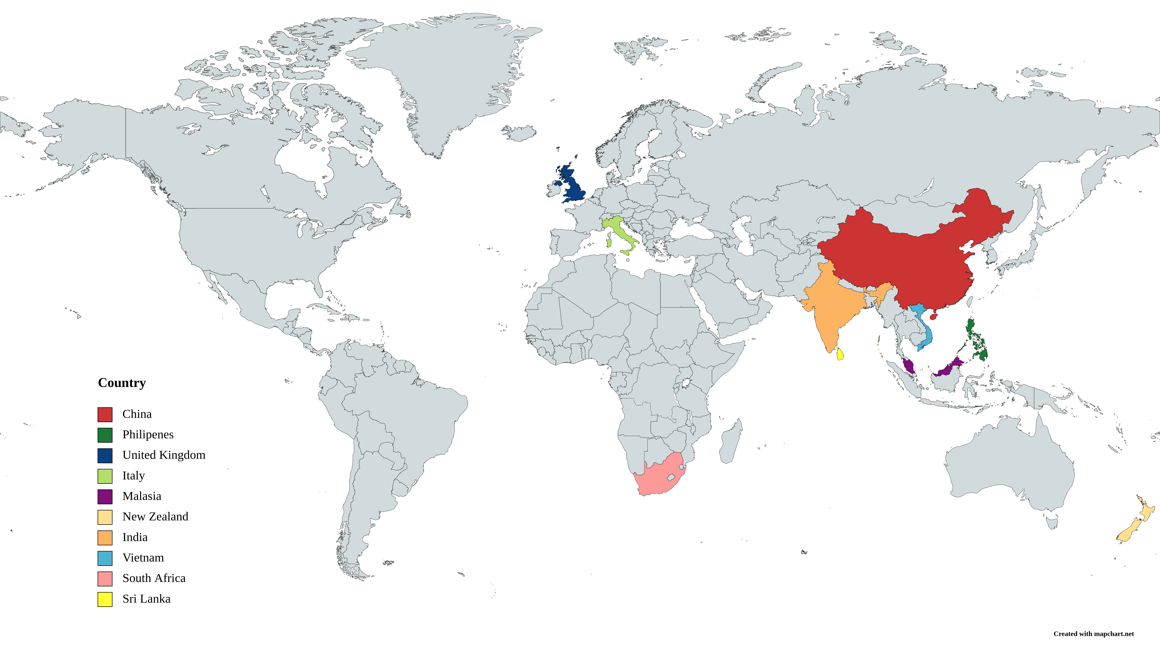

1. In a paragraph, ***explain*** the impact of changes in population in Australia over the past 70 years. Hint – this is useful practice for your upcoming assignment!

The population is more culturally diverse making it’s citizens have many cultural beliefs, food, customs and ways of living.

**Check Your Learning – Page 231**

***Answer the following questions in full sentences:***

1. Who was Australia’s first Minister for Immigration? Which party did he represent?

Arthur Calwell was the first minister for immigration and represented the labour party

1. What were the two main requirements to be accepted as a migrant to Australia in the period after World War II?

The immigrants had to be anti-communist and white

1. Why did Glenn A Baker (Source 5.6) say the Snowy Mountains Scheme ‘changed the face of this country’?

It had the effect of bringing in many dirverse migrants to australia

1. Where did most migrants come from in the immediate post-war period?  
   The migrants came from Lithuania, Latvia Estonia, Poland ,Yugoslavia, Ukraine and Hungry
2. What does Arthur Calwell’s speech (Source 5.7) tell you about immigration policy after World War II?